PROG8170

Programming: SQA Techniques

# Assignment #1 – Defect Finding and Logging

**Due at the date / time specified in eConestoga for your class**

**50 Marks – worth 10%**

*This is an individual assignment. Do your own work and do not share your work with others. Sharing work is an Academic Offense and is subject to a penalty. Be aware that all source code and other documentation is automatically checked by eConestoga upon submission.*

For this assignment, we are going to use the MS Azure DevOps defect tracking system to log five issues for a very well-developed software application.

The instructions for setting up Azure DevOps are in the slides of Week 02. When setting up your project in Azure DevOps, please name the project as follows (where FirstName and LastName are your individual particulars -10% for not performing this):

## FirstName_LastName_A1

To assist you in logging some meaningful defects, a simple JavaScript calculator application is available in eConestoga along with this Assignment. To use this file, you will need to install XAMPP and run the Apache server on your PC. Instructions for this are also found below.

You will need to:

1. download this file
2. unzip/extract the contents of it directly into the XAMPP\htdocs directory
3. start the Apache servers using the XAMPP Control Panel
4. navigate to the site in your browser as follows:

<http://localhost/prog8170>a01

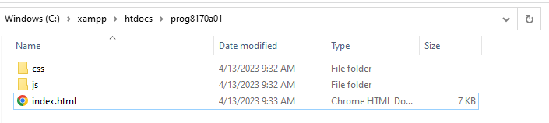

As you’re testing this application, you may encounter some defects. Your job now, is to log **four (4) defects** and **one (1) feature request** with this application using MS ADO. Ensure that you are using at least **four (4) different**, correct Severity levels in the logging of your defects.

Ensure that your defects in Azure DevOps contain a screenshot of the actual defect from the application as shown below. Each screenshot must look something like the following – ensuring that all fields are visible:

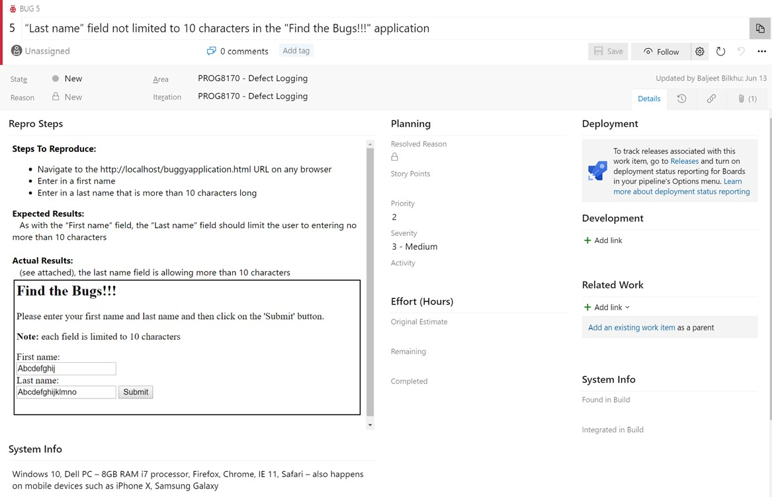

Actual defect from the application being shown

Paste that entire defect from MS ADO into your MS Word document.

Once you’ve found all the defects with this application, you will then submit a single, unzipped MS Word document that contains all of your defects:

* + as individual screenshots
  + a query showing following fields (in order):
    - ID
    - Title
    - Severity
    - Area Path
    - Created By:
    - Created Date:
  + as well as an overall view – a pie-chart of all the defects grouped by Severity

Once you’ve found all the issues with this application, you will then submit a single, unzipped MS Word document that contains all of your issues as individual screenshots as well as an overall view of all of the issues (defects and feature request) by Severity logged.

After having logged your defects, analyze the defects logged from this application and provide a recommendation for whether this application is ready to be released – be sure to defend your position by providing concrete examples of why or why not.

The Requirements for this application are as follows:

* This application will allow the user to enter in two numbers by clicking on the number itself from the numeric pad using the mouse and/or the keyboard
* The user can then perform the add, subtract, multiply or divide operations on these numbers (as they would on a standard handheld calculator)
* Once the result of an operation is shown, the user should not be able to append to it
* The calculator also shows the date and time (which are automatically updated without the user requiring to refresh)
* The correct result of the selected operation will then be shown with up to eight decimal places
* There should be a link taking the user back to the home page of this site
* The User Interface should be showing a light-blue background with black buttons, must be free of spelling / grammatical errors and will present two lines in the ribbon
* The application must be operational on the latest Microsoft Edge browser and either of the latest versions of FireFox or Chrome and must not crash under any circumstances
* Keyboard shortcuts are as follows:
  + Backspace (clear) – deletes one number at a time to the left
  + Escape (all clear) – clears the entire ribbon
  + Enter (equals) – executes the calculation
  + Numeric digits – inputs the typed digit into the ribbon
* There must also be a copyright date (with only the year) shown on this application

## XAMPP Installation

If you haven’t installed XAMPP yet, please find the instructions here:

Download the latest version of XAMPP from here: <https://www.apachefriends.org/download.html>

Start the XAMPP Control Panel after the installation:

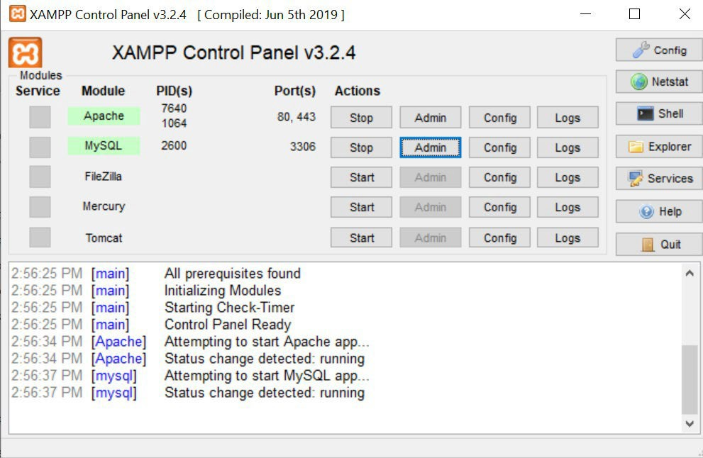

(the XAMPP Control Panel is available in the directory where you installed XAMPP with the filename: xampp- control.exe). Click on the “Start” button for the Apache server.

# Submissions

The format for submitting the assignment is as follows:

1. eConestoga submissions:

A single, unzipped MS Word document named:

**FirstName_LastName_StudentID_Assignment1.docx** (where First_Name, Last_Name and StudentID are your particulars) that contains:

* 1. Assignment Title Page with your name, student ID, “Assignment #1” in the title and date;
  2. A listing of all of the issues logged as screenshots

## [30 Marks]

* 1. Screenshot of the overall defects logged sorted by Severity – showing the query used and the pie-chart as screenshots

## [15 Marks]

* 1. Analysis of the defects logged and a definite recommendation provided as to the disposition of the application

## [5 Marks]

* 1. Please submit to the **“Assignment 01”** assignment folder in eConestoga.

**Late penalties will apply for any late submissions.**

**A -10% penalty will be applied for any files that are zipped up or not using the correct naming format.**

**As this is a technical report, proper spelling and grammar will also be required and marks may be lost for reports that have poor spelling and / or grammar.**

**A more detailed marking scheme is shown in the Rubric associated with the Assignment Folder in eConestoga.**